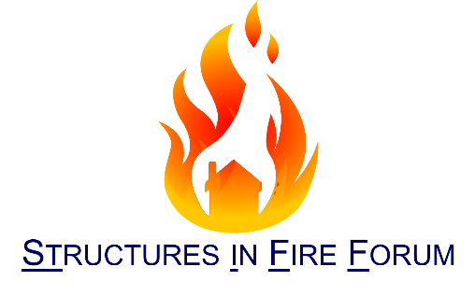
Structures in Fire Forum – 12th April 2016
IStructE HQ, Bastwick Street, London
Provisional Agenda:
10.30 – 11.00 Coffee
“Re-use of waste tyre fibres to prevent fire-induced spalling – some initial testing”
Shan-shan Huang, University of Sheffield
“New Approach to fire safe application of fibre-reinforced polymer reinforcement for concrete”
Mohammed Kiari, University of Edinburgh
Fibre-reinforced polymer (FRP) reinforcement have many advantages over traditional steel reinforcement, most notably lack of corrosion. However, widespread application of FRP as internal reinforcement for concrete structures remains limited due to FRP’s bond degradation with concrete at elevated temperature as in event of fire. The research presented a new approach of FRP loops as internal reinforcement for fire performance. A series of four-point bending tests of concrete beams reinforced with FRP loops were prepared and tested at ambient and elevated temperatures. Results confirm the effectiveness of the novel approach, with significant improvement of fire resistance time and reduced deflection.
“Improving fire resistance of existing concrete slabs by concrete topping”
Tom Molkens, Stubeco
The validity of Eurocode 2 part 1-2 is limited to the new design of buildings and civil engineering works in concrete, however there is a desire to retrofit some structures for new purposes. These buildings having been designed using other require the same standards of REI as new builds. This presentation looks at an example of using current design codes to retrofit an existing structure.
13.00 – 14.00 Sandwich Lunch
“Why don’t more sandwich panel ceilings collapse in fire”
Gordon Cooke, Cooke on Fire
Presentation deals with loss of stability of steel-faced sandwich panels in fire when used as ceilings. Modes of failure are illustrated and calculation method is described which has been adopted in the EN Extended Application document now used for assessing stability of long span panel assemblies in Europe. Raises question ‘Why don’t we hear more about panel failures in fire?’
“Reliability methods for structural fire engineering”
Ruben van Coile, WSP

“Blade Columns – an EC2 discussion”
Graham Flint, Arup
15.30 Tea

